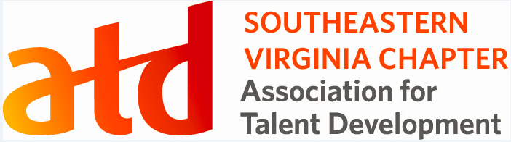

The Southeastern Virginia Chapter, a non-profit association affiliate of the Association of Talent Development. Their programs are intended to provide members with professional education related to Talent Development and provide continuing education credits for certified members.

We appreciate your interest in submitting a proposal to share your experience and expertise.

Program Information
All programs are held on the second Tuesday of the month from 6 pm-8 pm and are for one (1.25) hour.

Chapter programming events are scheduled for the months of Feb-May and August-November.

Special chapter programming is scheduled for the months of June and July. Speakers and/or presenters may be requested based on these special events.

Please ensure the desired presentation date is noted on the form. All proposals must be submitted seven weeks before the month the speaker is requesting to present. This is necessary for the proper promotion and confirmation. We ask that all presentations be hands-on with direct takeaways for professionals to apply immediately.

We desire that presentations are aligned with the ATD Talent Development Capability Model,
(as shown at the end of this form). We follow the ATD Capability model structure by presenting Building Personal Capability in the first quarter of the year, followed by Development in Professional Capabilities in the second quarter, and then Impacting Organizational Capabilities in the third quarter of the year.
The program will be discussed and reviewed by the VP of Programming before formal submission if desired to ensure proper content and focus.

Submitting Program Proposal
All requests to present at a chapter meeting require:

- Completed "Request to Present" form
- Presentation materials (handouts, PowerPoint, speaker notes, etc.) in their final format
- Personal biography (included in "Request to Present" form) and photo (preferably PNG)
- All materials must be in Word and PowerPoint format when submitted
- Speakers may provide additional proof of performance (videotapes, evaluations from past speaking engagements or letters of recommendation, etc.) to enhance their submission, but it is not required.
- Once approved, you will be asked to submit a 60-second or less video on who you are and the topic you will present for event marketing purposes.

Submit materials to the VP of Programming (2018programs.sevaatd@gmail.com). Incomplete submissions will not be considered.

Program Confirmation
If approved by the chapter board, program submissions will be reviewed and tentatively scheduled for the date requested. Final confirmation will be sent via e-mail four weeks in advance of the scheduled meeting. If more than one proposal for a particular date is received, preference will be given to the first received and completed submission.

Honoraria/Fees
SEVA ATD seeks contributors who are willing to share their expertise "In-Kind" to promote Talent Development professionals' development. We are unable to provide an honorarium. The chapter board at this date is unable to approve any program fees.

Presentation Equipment
The presenter should have access to a personal desktop computer to access the presentation platform (provided by SEVA ATD).

Travel Expenses
Until further notice, we will only have virtual contact events due to COVID.

Presenter Agreement
Approved presenters are required to:
- Bring the approved presentation on a desktop computer compatible with our virtual presentation platforms (Zoom, StreamYard, Facebook Live, MS Teams, etc.)
- Provide electronic handouts (as submitted with "Request to Present")
- Retain the session content and audio/visual needs as originally submitted
- Provide prior notice of any changes in the identity or number of presenters
- Honor commitment to provide education or services without showcasing the provider's practice, services, or products (i.e., no selling from the podium); and
- Present themselves in a professional, respectful manner.

2021 REQUEST TO PRESENT FORM

Professional  Designation | APTD CPTD LSS PMP SHRM-CP SHRM-SCP Ph.D. Esquire
Salutation | Miss. Ms. Mrs. Mr. Dr.
Full Name |  | Title
Company Name
Phone Number
E-mail Address

Presentation Date Requested (meetings are the 2nd Tuesday of each month):

Program Fee: $0

Travel expenses (type and cost): None due to virtual meeting platform and COVID restrictions

List Co-presenter Name and Title (if applicable):

1)
2)

Have you provided a service or presented at a SEVA ATD event in the past? No/Yes - please describe.

Please list previous speaking or service experience and reference contact information:
Event | Contact Name | Contact Phone/E-mail

Are you a SEVA ATD or ATD National Member? Yes No

All sections must be completed before submitting for approval to be considered.

Program Title:

Length of Program: Presentation length, 75 minutes + Q&A minutes = Total: 1 hour 15 mins

Abstract of Program: In 150 words or less, please summarize the program's contents. SEVA ATD may change and or reduce your title/description for clarity. Identify the title and keywords that the program correlates to the Talent Development Capability Model.

Learning Objectives: Describe the program's top three learning or service objectives.
1)
2)
3)

Biography: In 150 words or less, please provide your biography or all presenters/authors' biographies included in your program. SEVA ATD may reduce the biography for publication and marketing purposes.

Program Documents
Please include information and/or supporting documentation to describe and explain your proposal. Please submit enough information to allow the chapter board to evaluate your proposal's merits.

List of supporting documents/handouts:
1)
2)
3)

Additional Information: Provide any other information that would help assess the quality or content of the program proposed.

Submittal
Complete these forms, save and include them with all program documents. Form and materials must be e-mailed to 2018programs.sevaatd@gmail.com no later than seven weeks before the month requested to present.

Talent Development Capability Model

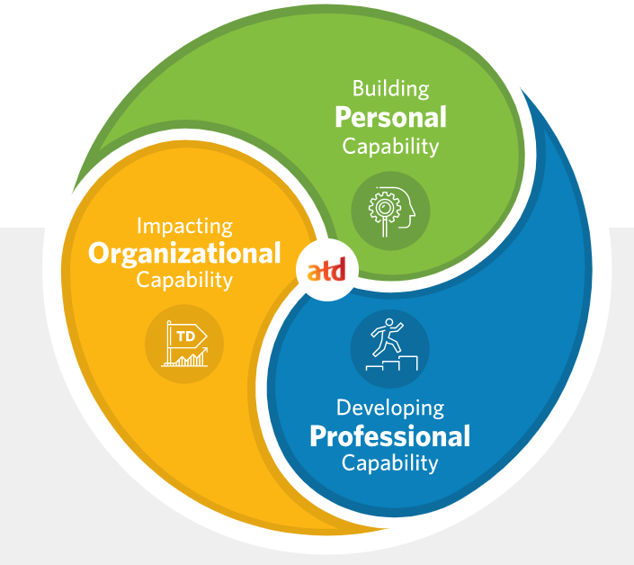

Building Personal Capability- This domain of practice embodies the foundational or enabling abilities all working professionals should possess to be effective in the business world. These largely interpersonal skills often called soft skills, are needed to build influential organizational or team culture, trust, and engagement.

- Communication
- Emotional Intelligence and Decision-Making
- Collaboration and Leadership
- Cultural Awareness and Inclusion
- Project Management
- Compliance and Ethical Behavior
- Lifelong Learning

Developing Professional Capability- Organizations with highly effective learning programs incorporate key principles from the learning sciences, the interdisciplinary research-based field that works to understand learning further, learning innovation, and instructional methodologies. Talent development professionals applying best practice will understand and apply foundational learning theories, adult learning theory principles, and cognitive science to design, develop, and deliver solutions that maximize outcomes.

- Learning Sciences
- Instructional Design
- Training Delivery and Facilitation
- Technology Application
- Knowledge Management
- Career and Leadership Development
- Coaching
- Evaluating Impact

Impacting Organizational Capability- This domain of practice embodies the knowledge, skills, and abilities needed by professionals to ensure talent development is a primary mechanism driving organizational performance, productivity, and operational results.

- Business Insight
- Consulting and Business Partnering
- Organization Development and Culture
- Talent Strategy and Management
- Performance Improvement
- Change Management
- Data and Analytics
- Future Readiness

