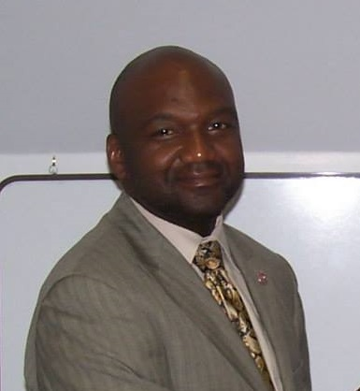
Kenneth (Maddog) Madison
“Connecting People to Their Potential”
Nominee for CFO and VP of Marketing

My name is Kenneth Madison, and I prefer to be called “Maddog” but most call me Ken. I reside in the Norfolk, Virginia area, and I am originally from Tuscaloosa, Alabama. I am a retired military officer and a workforce education and development professional. My gift is that I think critically and creatively almost simultaneously. Over my 12 years of direct workforce experience, I have earned a reputation as an exceptional presenter and coach. I am enrolled in the MS Instructional Design and Technology program at Walden University. I have two bachelor’s degrees; one in Business Administration from Stillman College and a second in Workforce Education and Development from Southern Illinois University (Oceana Campus). I also have over 30 years of hands on experience working with a non-profit fraternity while in college and after graduation. I have served on numerous boards and committees and understand marketing needs.

