The Southeastern Virginia Chapter, a non-profit association affiliate of the Association of Talent Development. Programs are intended to provide members with professional education related to the field of
Talent Development and to provide continuing education credits for certified members.

We appreciate your interest in submitting a proposal to share your experience and expertise.

Program Information
All programs are held on the second Tuesday of the month from 6pm-8pm and are for one (1 1/4) hour.
No programs are scheduled for July and December. Please ensure the desired presentation date is noted on
the form.

All proposals must be submitted 7 weeks prior to the month the speaker is requesting to present.
This is necessary for the proper promotion and venue confirmation. We request that all presentations are
hands-on and have immediate take-aways that any average professional will be able to immediately use.

It is our desire that presentations are based on the ATD Competency Model as shown at the end of this form:
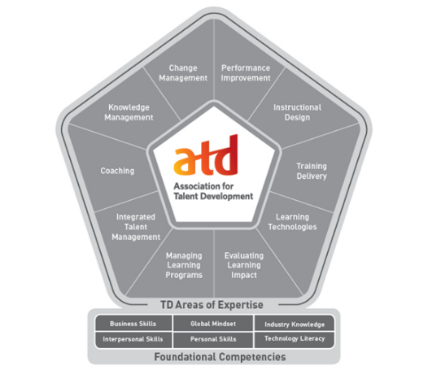
The program will be discussed and reviewed by the Director of Programs prior to formal submission if desired to ensure proper content and focus.

Submitting Program Proposal
All requests to present at a chapter meeting require:
- Completed “Request to Present” form
- Presentation materials (handouts, PowerPoint, speaker notes, etc.) in their final format
- Personal biography (included in “Request to Present” form) and photo (preferably PNG)
- All materials must be in Word and PowerPoint format when submitted
- Speakers may provide additional proof of performance (videotapes, evaluations from past speaking engagements or letters of recommendation, etc.) to enhance their submission but it is not required.

Submit materials to the Director of Programs (membership.sevaatd@gmail.com). Incomplete submissions will not be considered.

Program Confirmation
Programs submissions will be reviewed and if approved by the chapter tentatively scheduled for the date requested. Final confirmation will be sent via email four weeks in advance of the scheduled meeting. If more than
one proposal for a certain date is received, preference will be given to the first received complete submission.

Honoraria/Fees
SEVA ATD seeks contributors who are willing to share their expertise to promote the development of Talent
Development professionals. We are unable to provide an honorarium.

Occasionally the chapter will approve program fees and must be noted in the “Request to Present” form to be
reviewed for approval.

Presentation Equipment
Some of our venue location provides all the necessary equipment for a feasible presentation. If there are
special circumstances the presenter will be informed in a timely manner.

However, the presenter should provide any additional equipment, including a laptop, as required for the
program.

Travel Expenses
The chapter does occasionally approve travel expenses for presenters outside the Hampton Roads area. These expenses must be identified in the “Request to Present” form at time of submission. Expenses will only be reimbursed per the approval of the chapter president.

Presenter Agreement
Approved presenters are required to:
- Presenter must bring the approved presentation on a computer compatible with projector equipment
- Provide their own handouts (as submitted with “Request to Present”)
- Retain the session content and audio/visual needs as originally submitted;
- Provide prior notice of any changes in the identity or number of presenters;
- Honor commitment to provide education or services without showcasing the provider’s practice, services or products (i.e. no selling from the podium); and
- Present themselves in a professional, respectful manner.

2017 REQUEST TO PRESENT FORM

Professional  designation | CPLP LSS PMP PHR SPHR GPHR Ph.D. Esquire
Salutation | Ms. Mrs. Mr. Dr.
Full Name |  | Title
Company Name
Phone Number
E-mail Address

Presentation date requested (meetings are the 2nd Tuesday of each month):
Program fee: 0

Travel expenses (type and cost): 0

List co-presenter name and title:

1)
2)

Have you provided a service or presented at a SEVA ATD event in the past? No Yes - please describe.

Please list previous speaking or service experience and reference contact information:
Event | Contact Name | Contact Phone/Email

Are you a SEVA ATD or ATD National Member? Yes No

All sections must be completed prior to submitting for approval in order to be considered.

Program Title:

Length of Program: Presentation length, 75 minutes + Q&A minutes = Total: 1 hour 15 mins

Abstract of Program: In 150 words or less, please summarize the contents of the program. SEVA ATD may
change and/or reduce your title/description for clarity.

ATD Competency Model: Identify the title and key words that the program correlates to the ATD Competency Model. For reference, the “Competency Model” is attached at the end of this form.

Learning Objectives: Describe the top three learning or service objectives of the program.
1)
2)
3)

Biography: In 150 words or less, please provide your biography or the biographies of all presenters/authors included in your program. SEVA ATD may reduce the biography for publication.

Program Documents
Please include here information and supporting documentation to describe and explain your Proposal. Please submit enough information to allow the relevant personnel to evaluate the merits of your proposal.

List of supporting documents / handouts:
1)
2)
3)

Additional Information: Provide any other information that would be helpful in assessing the quality or
content of the program proposed.

Submittal
Complete these forms, save, and include with all program documents. Form and materials must be emailed to membership.sevaatd@gmail.com no later than 7 weeks prior to the month requested to present.

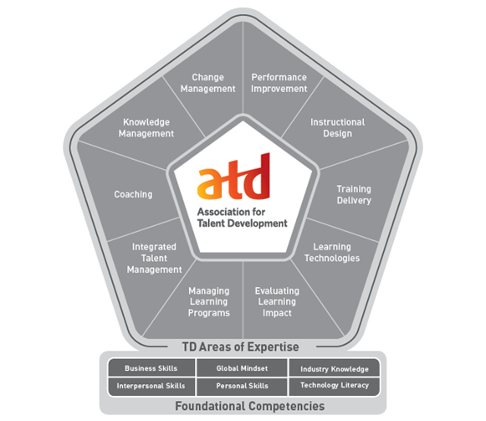
ATD Competency Model

https://www.td.org/Certification/Competency-Model

PERFORMANCE IMPROVEMENT
Ability to apply a systematic process for analyzing human performance gaps and for closing them.

INSTRUCTIONAL DESIGN
Ability to design and develop informal and formal
learning solutions using a variety of methods.

TRAINING DELIVERY
Ability to deliver informal and formal learning
solutions in a manner that is both engaging and
effective.

LEARNING TECHNOLOGIES
Ability to apply a variety of learning technologies to address specific learning needs.

EVALUATING LEARNING IMPACT
Ability to use learning metrics and analytics to measure the impact of learning solutions.

MANAGING LEARNING PROGRAMS
Ability to provide leadership to execute the organization’s people strategy; implements training projects and activities.

INTEGRATED TALENT MANAGEMENT
Ability to build an organization’s culture, capability, capacity, and engagement through people development
strategies.

COACHING
Ability to apply a systematic process to improve others’ ability to set goals, take action, and maximize strengths.

KNOWLEDGE MANAGEMENT
Ability to capture, distribute, and archive intellectual capital to encourage knowledge-sharing and collaboration.

CHANGE MANAGEMENT
Ability to apply a systematic process to shift individuals, teams, and organizations from current state to desired state.

